1. **Write a JavaScript program that prompts the user to enter two integers. Once obtained, the program outputs HTML text displayed in the browser indicating which number is greater than the other. If the two numbers are equal, it displays the message “The two numbers are equal”. The text must be displayed within <h1> tags.**

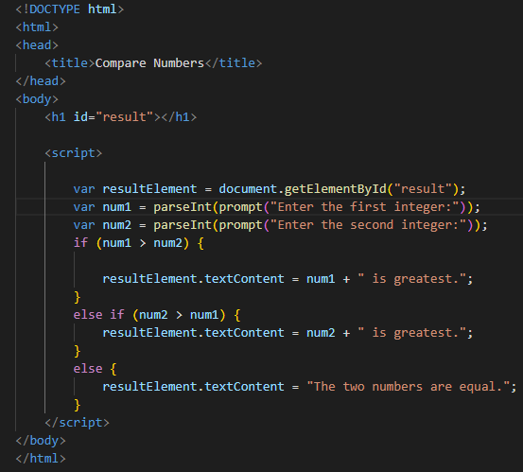

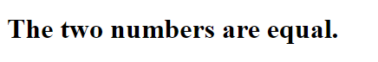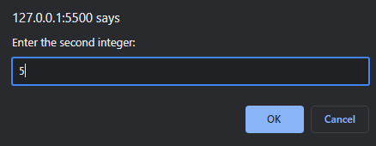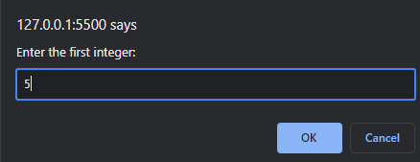

1. **Modify the JavaScript program done in Question 1 by changing the way output is displayed. In this part, you are expected to output the same text in an alert window.**

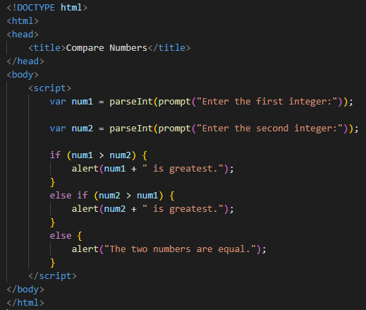

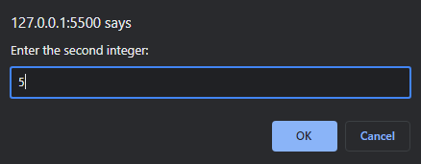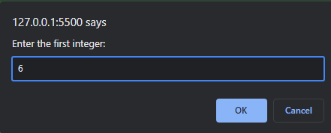

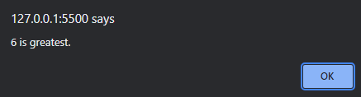

1. **Write a JavaScript program that asks the user to input five integer numbers to determine the sum of the numbers and outputs the result to the browser window. You are expected to use a while loop to perform repeated operations. Followed by a for loop to achieve the same task.**

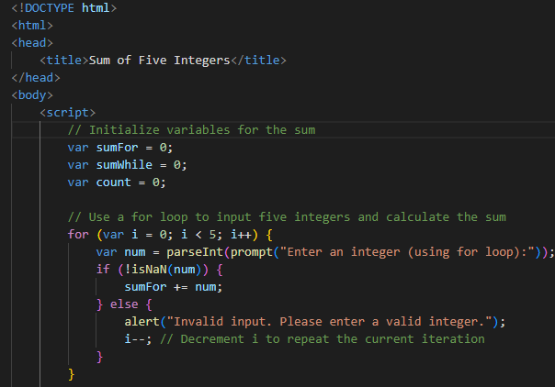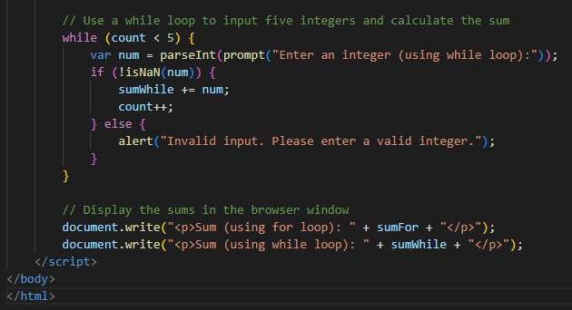

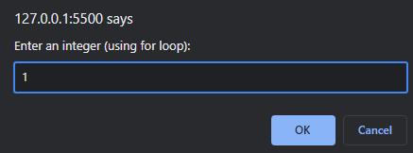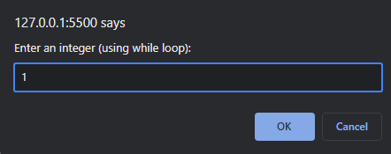

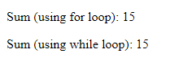

**Here, I took 5 numbers that were 1, 2,3,4,5 for both for and while loop.**